MARKET BASKET INSIGHTS



|  |  |
| --- | --- |
| **Team members name** | **Mail id** |
| Abinaya. K | abinayak2020@gmail.com |
| Dhanalakshmi.S | dhanalakshmisekar26@gmail.com |
| Kokila.M | kokila071004@gmail.com |
| Mahalakshmi. R | maha606105@gmail.com |

**Problem Statement:**

In the dynamic landscape of modern retail, understanding customer behavior and optimizing product offerings are critical for enhancing revenue, customer satisfaction, and operational efficiency. Our organization seeks to leverageMarket Basket Analysis (MBA) to gain actionable insights from transaction data. The primary goal is to uncover hidden patterns, associations, and relationships among purchased items, ultimately leading to strategic decisions that will benefit our business.

**Data preprocessing:**

df_ = pd.read_csv("../input/market-basket-analysis/Assignment-1_Data.csv", sep = ";")

df = df_. copy ()

/opt/conda/lib/python3.7/site-packages/IPython/core/interactiveshell.py:3444: DtypeWarning: Columns (0) have mixed types.Specify dtype option on import or set low_memory=False.

exec (code_obj, self.user_global_ns, self.user_ns)

df.head(10)

def check_df(dataframe, head=5):

print ("##################### Shape #####################")

print(dataframe.shape)

print ("##################### Types #####################")

print(dataframe.dtypes)

print ("##################### Head #####################")

print(dataframe.head(head))

print ("##################### Tail #####################")

print(dataframe.tail(head))

print ("##################### NA #####################")

print(dataframe.isnull(). sum ())

check_df(df)

##################### Shape #####################

(522064, 7)

##################### Types #####################

BillNo object

Itemname object

Quantity int64

Date object

Price object

CustomerID float64

Country object

dtype: object

##################### Head #####################

BillNo Itemname Quantity Date \

0 536365 WHITE HANGING HEART T-LIGHT HOLDER 6 01.12.2010 08:26

1 536365 WHITE METAL LANTERN 6 01.12.2010 08:26

2 536365 CREAM CUPID HEARTS COAT HANGER 8 01.12.2010 08:26

3 536365 KNITTED UNION FLAG HOT WATER BOTTLE 6 01.12.2010 08:26

4 536365 RED WOOLLY HOTTIE WHITE HEART. 6 01.12.2010 08:26

Price CustomerID Country

0 2,55 17850.0 United Kingdom

1 3,39 17850.0 United Kingdom

2 2,75 17850.0 United Kingdom

3 3,39 17850.0 United Kingdom

4 3,39 17850.0 United Kingdom

##################### Tail #####################

BillNo Itemname Quantity Date \

522059 581587 PACK OF 20 SPACEBOY NAPKINS 12 09.12.2011 12:50

522060 581587 CHILDREN'S APRON DOLLY GIRL 6 09.12.2011 12:50

522061 581587 CHILDRENS CUTLERY DOLLY GIRL 4 09.12.2011 12:50

522062 581587 CHILDRENS CUTLERY CIRCUS PARADE 4 09.12.2011 12:50

522063 581587 BAKING SET 9 PIECE RETROSPOT 3 09.12.2011 12:50

Price CustomerID Country

522059 0,85 12680.0 France

522060 2,1 12680.0 France

522061 4,15 12680.0 France

522062 4,15 12680.0 France

522063 4,95 12680.0 France

##################### NA #####################

BillNo 0

Itemname 1455

Quantity 0

Date 0

Price 0

CustomerID 134041

Country 0

dtype: int64

# Drop na values

df.dropna(inplace=True)

# Quantity and Price should be greater than 0

df = df[df["Quantity"] > 0]

# We have to change the price column datatype as a numeric

df ['Price'] = pd.to_numeric(df['Price'], errors='coerce')

df = df[df["Price"] > 0]

check_df(df)

##################### Shape #####################

(1537, 7)

##################### Types #####################

BillNo object

Itemname object

Quantity int64

Date object

Price float64

CustomerID float64

Country object

dtype: object

##################### Head #####################

BillNo Itemname Quantity Date \

45 536370 POSTAGE 3 01.12.2010 08:45

237 536392 RUSTIC SEVENTEEN DRAWER SIDEBOARD 1 01.12.2010 10:29

377 536403 POSTAGE 1 01.12.2010 11:27

1113 536527 POSTAGE 1 01.12.2010 13:04

4348 536779 Bank Charges 1 02.12.2010 15:08

Price CustomerID Country

45 18.0 12583.0 France

237 165.0 13705.0 United Kingdom

377 15.0 12791.0 Netherlands

1113 18.0 12662.0 Germany

4348 15.0 15823.0 United Kingdom

##################### Tail #####################

BillNo Itemname Quantity Date Price CustomerID \

521357 581493 POSTAGE 1 09.12.2011 10:10 15.0 12423.0

521375 581494 POSTAGE 2 09.12.2011 10:13 18.0 12518.0

521885 581570 POSTAGE 1 09.12.2011 11:59 18.0 12662.0

521922 581574 POSTAGE 2 09.12.2011 12:09 18.0 12526.0

521923 581578 POSTAGE 3 09.12.2011 12:16 18.0 12713.0

Country

521357 Belgium

521375 Germany

521885 Germany

521922 Germany

521923 Germany

##################### NA #####################

BillNo 0

Itemname 0

Quantity 0

Date 0

Price 0

CustomerID 0

Country 0

dtype: int64

**Data Visualization:**

total_sales = df

total_sales["Total_Price"] = total_sales["Price"] * total_sales["Quantity"]

#total_sales. columns

total_sales_per_customer = total_sales.groupby(["CustomerID", "Country"]).agg({"Total_Price": "sum"})

total_sales_per_customer.head(10)

Top 10 Shoppers and Their Coutries

total_sales_per_customer.reset_index(inplace=True)

total_sales_per_customer.sort_values(by = "Total_Price", ascending = False). head (10)

# Consider that for all time period

data_fig = total_sales_per_customer.sort_values(by = "Total_Price", ascending = False). head (100)

fig = px.scatter(data_fig, x="CustomerID", y="Total_Price",

size="Total_Price", color="Country",

hover_name="Country", log_x=True, size_max=60, title="Top 100 Shoppers and Their Contries & Shopping Amounts")

fig.show()

total_sales_per_customer.groupby(["Country"]).agg({"Total_Price":"sum"}).reset_index().sort_values(by="Total_Price", ascending=False)

data = total_sales_per_customer.groupby(["Country"]).agg({"Total_Price":"sum"}).reset_index().sort_values(by="Total_Price", ascending=False)

fig = px.bar(data, x='Country', y='Total_Price', title = "Shopping Amounts by Countries")

Fig.show()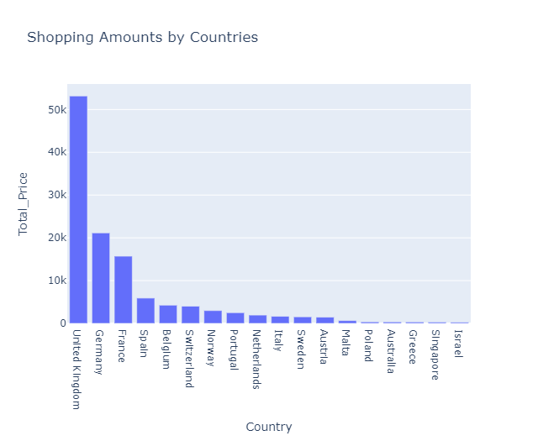

**Association Analysis and Generating Insights:**

Step 1: Data Preparation

Collect Data: Gather your transaction data, which should be organized in a format where each row represents a unique transaction, and columns represent items purchased.

Data Cleaning: Ensure that your data is clean and structured. Remove duplicates and handle any missing values.

Step 2: Install Required Libraries:

import pandas as pd

import numpy as np

from mlxtend.frequent_patterns import apriori, association_rules

import plotly.express as px

Step 3:

# Convert the data into a binary format

basket_sets = df.groupby(['TransactionID', 'Item']) ['Quantity']. sum (). unstack().reset_index().fillna(0)

basket_sets = basket_sets.set_index('TransactionID')

# Convert item quantities into binary values (0 or 1)

def encode_units(x):

if x <= 0:

return 0

if x >= 1:

return 1

basket_sets = basket_sets.applymap(encode_units)

# Perform Apriori Algorithm

frequent_itemsets = apriori(basket_sets, min_support=0.05, use_colnames=True)

# Generate Association Rules

rules = association_rules(frequent_itemsets, metric="lift", min_threshold=1.0)

# Display the association rules

print(rules)

This code will find frequent itemsets and generate association rules based on your market basket data. You can adjust the **min_support** and **min_threshold** values according to your specific dataset and business requirements.

**Output:**

antecedent consequent support confidence lift

0 (bread,) (milk,) 0.600000 0.800000 1.333333

1 (milk,) (bread,) 0.600000 0.750000 1.250000